Question 1:

Write a Java Program to create a new file.

Week 13

*Main.java*

Code:

package file;  
import java.io.*;  
public class Main {  
 public static void main(String[] args) throws IOException {  
 File file = new File("TestFile.txt");  
 boolean isFileCreated = file.createNewFile();  
 System.*out*.println( (isFileCreated) ? "File Created." : "File Not Created." );  
 }  
}

"C:\Program Files\Java\OpenJDK\jdk-25\bin\java.exe" "-javaagent:C:\Program Files\JetBrains\IntelliJ IDEA 2025.2.1\lib\idea_rt.jar=59644" -Dfile.encoding=UTF-8 -Dsun.stdout.encoding=UTF-8 -Dsun.stderr.encoding=UTF-8 -classpath "D:\Uni Material\LAB\sem 3\Week 13\Question1\target\classes" file.Main

File Created.

Process finished with exit code 0

Output:

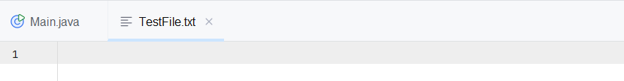

*test.txt*

Question 2:

Write a Java Program to write into a file.

*Main.java*

Code:

package file;  
import java.io.IOException;  
import java.io.FileWriter;  
public class Main {  
 public static void main(String[] args) {  
 try (FileWriter fw = new FileWriter("test.txt", true)) {  
 fw.write("Hello World.");  
 System.*out*.print("File has been written successfully.");  
 } catch (IOException e) {  
 System.*out*.println("IOException occurred: " + e.getMessage());  
 }  
 }  
}

Output:

"C:\Program Files\Java\OpenJDK\jdk-25\bin\java.exe" "-javaagent:C:\Program Files\JetBrains\IntelliJ IDEA 2025.2.1\lib\idea_rt.jar=52486" -Dfile.encoding=UTF-8 -Dsun.stdout.encoding=UTF-8 -Dsun.stderr.encoding=UTF-8 -classpath "D:\Uni Material\LAB\sem 3\Week 13\Question2\target\classes" file.Main

File has been written successfully.

Process finished with exit code 0

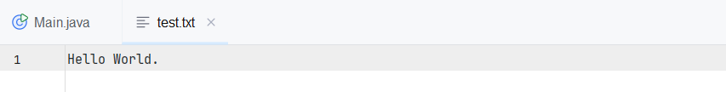

*test.txt*

Code:

Write a Java Program to copy one file into another file.

Question 3:

package file;  
import java.io.*;  
public class Main {  
 public static void main(String[] args) {  
 try {  
 BufferedReader br = new BufferedReader(new FileReader("QuotesFromGoogle.txt"));  
 BufferedWriter bw = new BufferedWriter(new FileWriter("ChairManSpeech.txt", true));  
 String line;  
 while ((line = br.readLine() )!= null) {  
 bw.write(line);  
 bw.newLine();  
 }  
 bw.flush();  
 bw.close();  
 br.close();  
 } catch ( IOException e) {  
 System.*out*.println("Error: " + e.getMessage());  
 }  
 }  
}

*Main.java*

Output:

"C:\Program Files\Java\OpenJDK\jdk-25\bin\java.exe" "-javaagent:C:\Program Files\JetBrains\IntelliJ IDEA 2025.2.1\lib\idea_rt.jar=56871" -Dfile.encoding=UTF-8 -Dsun.stdout.encoding=UTF-8 -Dsun.stderr.encoding=UTF-8 -classpath "D:\Uni Material\LAB\sem 3\Week 13\Question3\target\classes" file.Main

Process finished with exit code 0

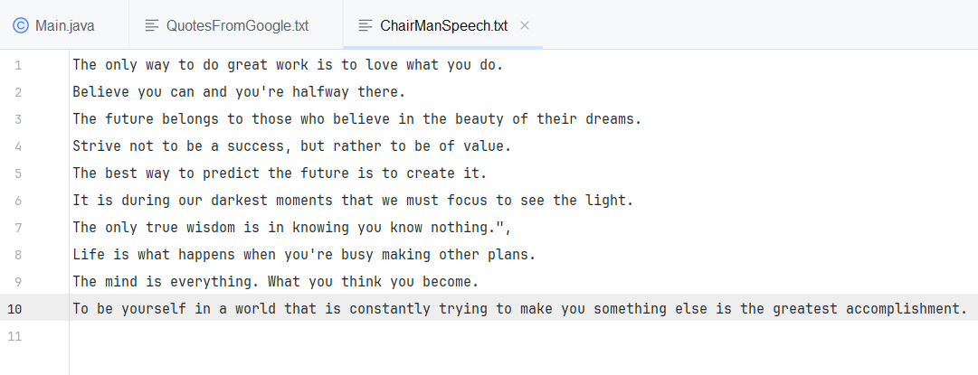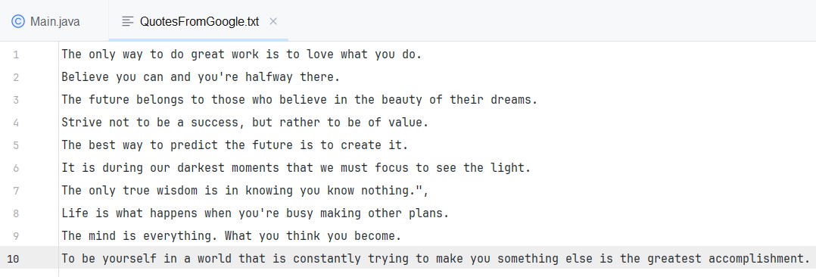

*QuotesFromGoogle.txt*

*ChairManSpeech.txt*

Code:

*Main.java*

Write a java program to find total no. of characters in a file.

Question 4:



package file;  
import java.io.*;  
public class Main {  
 public static void main(String[] args) {  
 int count = 0;  
 try {  
 FileReader fr = new FileReader("Quotes.txt");  
 int ch;  
 while ((ch = fr.read()) != -1) {  
 count++;  
 }  
 fr.close();  
 System.*out*.println("Total characters in file: " + count);  
 } catch (IOException e) {  
 System.*out*.println("Error: " + e.getMessage());  
 }  
 }  
}

"C:\Program Files\Java\OpenJDK\jdk-25\bin\java.exe" "-javaagent:C:\Program Files\JetBrains\IntelliJ IDEA 2025.2.1\lib\idea_rt.jar=65233" -Dfile.encoding=UTF-8 -Dsun.stdout.encoding=UTF-8 -Dsun.stderr.encoding=UTF-8 -classpath "D:\Uni Material\LAB\sem 3\Week 13\Question4\target\classes" file.Main

Total characters in file: 625

Process finished with exit code 0

Output:

*Quotes.txt*



*Main.java*

*Quotes.txt*

Output:

"C:\Program Files\Java\OpenJDK\jdk-25\bin\java.exe" "-javaagent:C:\Program Files\JetBrains\IntelliJ IDEA 2025.2.1\lib\idea_rt.jar=56516" -Dfile.encoding=UTF-8 -Dsun.stdout.encoding=UTF-8 -Dsun.stderr.encoding=UTF-8 -classpath "D:\Uni Material\LAB\sem 3\Week 13\Question5\target\classes" file.Main

Total lines in file: 10

Process finished with exit code 0

Code:

Write a java program to find total no. of lines in a file.

Question 5:

package file;  
import java.io.*;  
public class Main {  
 public static void main() {  
 int lineCount = 0;  
 try {  
 BufferedReader br = new BufferedReader(new FileReader("Quotes.txt"));  
 String line;  
 while ((line = br.readLine()) != null) {  
 lineCount++;  
 }  
 br.close();  
 System.*out*.println("Total lines in file: " + lineCount);  
 } catch (IOException e) {  
 System.*out*.println("Error: " + e.getMessage());  
 }  
 }  
}